How to use post man with Dynamics crm.

1. Install Postman in system(<https://www.getpostman.com/downloads/>)
2. Create new environment.

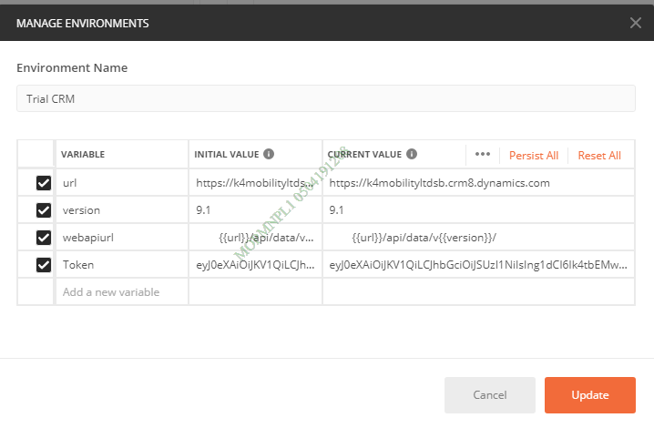

**Sample**

Name- Trail CRM

|  |  |  |
| --- | --- | --- |
| **Variable** | **Initial Value** | **Current Value** |
| url | https://k4mobilityltdsb.crm8.dynamics.com | https://k4mobilityltdsb.crm8.dynamics.com |
| version | 9.1 | 9.1 |
| webapiurl | {{url}}/api/data/v{{version}}/ | {{url}}/api/data/v{{version}}/ |
| Token | Enter token value | Enter token value |

**Get Token:**

1. Open <http://xrm.tools/>
2. Click on “Access Token”.

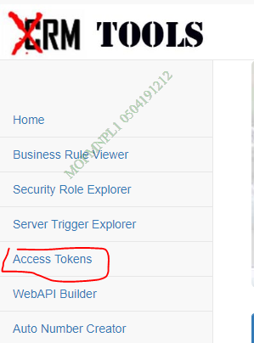

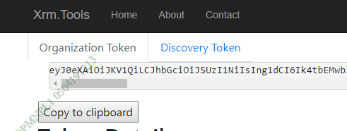

1. Copy Token.
2. Add Token in Postman your environment variable(Token).
3. Create new Request .

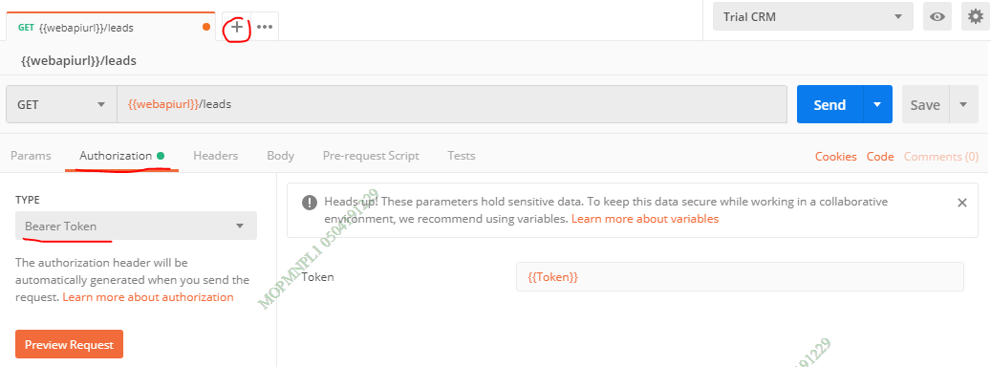

1. Go to “Authorization” tab.
   1. Select Type->Bearer Token
   2. Enter {{Token}} variable in token.

**Samples**

1. **Retrieve Multiple:-**

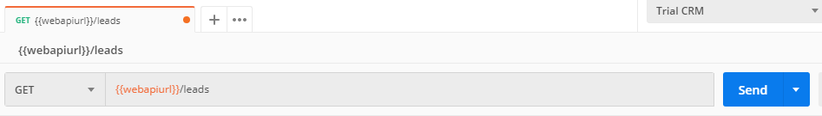

Select “Get” method.

Enter “{{webapiurl}}/entity plural name” and click on Send button.

1. **Using FetchXML**

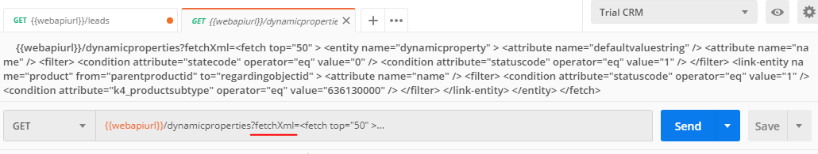

Select “Get” method.

Enter “{{webapiurl}}/entity plural name”fetchXml=your fetchxml query” and click on Send button.

1. **Retrieve**

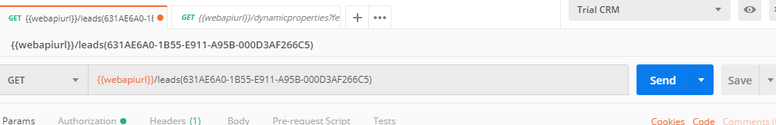

Select “Get” method.

Enter “{{webapiurl}}/entity plural name(Entity record Guid)” and click on Send button.

1. **Delete Record**

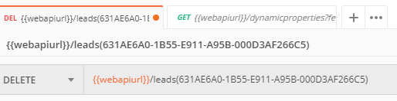

Select “DELETE” method.

Enter “{{webapiurl}}/entity plural name(Entity record Guid)” and click on Send button.

1. **Update**:-

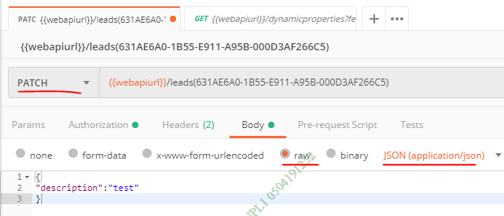

Select “PATCH” method.

Enter “{{webapiurl}}/entity plural name(Entity record Guid)”

Select Body Tab(Json(application/json)

Enter your information.

Click on Send button.

1. **Create**:-

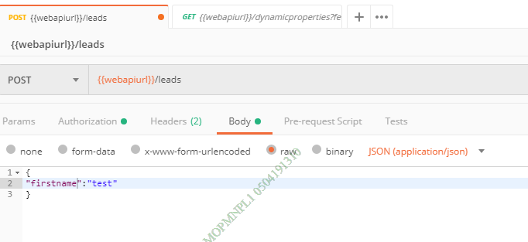

Select “POST” method.

Enter “{{webapiurl}}/entity plural name”

Select Body Tab(Json(application/json)

Enter your information.

Click on Send button.

Reference:-

<https://docs.microsoft.com/en-us/dynamics365/customer-engagement/developer/webapi/use-postman-perform-operations>